
Faculty

of

Computer

Applications

MCA Sem-1
(AY-2026-27)

Lab Book

Sub Code: 05MC0108 (DBMS)

Enrollment No : | 92600584022
Full Name : | Maheta Kunjal Vijaybhai

Sub.Faculty Name: Dr. Jaypalsinh A. Gohil

Index
Unit : 1 Exercise No | Unit : 1 Definition
1 | Write a PL/SQL block that find  1. Area Of Circle  2. Area Of Rectangle  3. Circumference of Circle
2 | Write a PL/SQL block to accept product name, qty and price from user and then calculate discount in Rs. based on the given (%).
3 | Write a PL/SQL block to calculate the total, percentage and grade of  student based on his/her Rollno from RESULT table. (Create RESULT  table with Rollno, Name, Sub1, Sub2, Sub3, Sub4, Sub5, Total, Per,  Grade attributes with appropriate data type).
4 | 1. Write a program that prints value 1 to 100 numbers using FOR LOOP.  2. Write a program that prints value 1 to 100 number using LOOP  Command.  3. Write a program that prints value 1 to 100 number using WHILE LOOP  Command
5 | Write a PL/SQL block which displays gross salary of employees as per user input EID. (Consider EMP table with EID, EName, Deptno,Deptname Gender, Age, BasicSal) with appropriate data types.) Gross_Salary: BASICSAL + (DA + HRA + Medical) – PF. Rules: HRA = 15% of basic, DA = 50% of basic, Medical = Rs. 500, PF = 10% of basic.
6 | Write a PL/SQL block which accepts measurement in feet and displays it in cm, inch and meter.
7 | Write a PL/SQL block which converts temperature from Celsius to Fahrenheit.
8 | Write a PL/SQL block to delete the record of employee for given EID.
9 | Write a PL/SQL block that calculates the simple interest based on given principal amount, rate of interest and number of years.
10 | Write a PL/SQL block to calculate the square and cube of the given number.

11 | Write a simple procedure that increases by the salary of employees for the given department no. by percentage inputted by the user using IN parameter. Also handle the exception if inputted department number not found.
12 | Write a procedure that search whether the given employee number is present or not in the table if present then print name, salary and department number of that employee. (Use both IN and OUT mode  variables) and also Write a PL/SQL block to call the SEARCH_EMP  procedure.
13 | Write a procedure that accept employee ID and remove records from  employee table. Also create a calling program to call procedure.
14 | Write a function that returns the age, category of an employee.  Categories:  ● Age < 18 → Minor  ● 18–60 → Adult  ● 60 → Senior
15 | Write a PACKAGE which includes Package Declaration, Package Body and call the individual object from the Package.

1. Write a PL/SQL block that find:
- Area of Circle
- Area of Rectangle
- Circumference of Circle

/*
Write a PL/SQL block that find
1.Area of circle(pi*radius*radius)
2.Area of Rectangle(length*width)
3.Circumference of circle(2*PI*RADIUS)
*/

ACCEPT CHOICE PROMPT "Enter Your Choice: 1.Area of circle ,2.Area of Rectangle ,3.Circumference of circle "
SET SERVEROUTPUT ON
SET VERIFY OFF
SET FEEDBACK OFF

DECLARE
CHOICE NUMBER:=&CHOICE;
PI NUMBER(7,2):=3.14;
RADIUS NUMBER(5);
LENGTH NUMBER(5);
WIDTH NUMBER(5);
BEGIN
--CHOICE:=&CHOICE;

DBMS_OUTPUT.PUT_LINE(' ');
IF (CHOICE=1) THEN
RADIUS:=&RADIUS;
DBMS_OUTPUT.PUT_LINE('Area of circle is : ' ||PI*(POWER(RADIUS,2)));
ELSIF (CHOICE=2) THEN
LENGTH:=&LENGTH;
WIDTH:=&WIDTH;
DBMS_OUTPUT.PUT_LINE('Area of Rectangle is : ' ||LENGTH*WIDTH);
ELSIF (CHOICE=3) THEN
DBMS_OUTPUT.PUT_LINE('Circumference of circle is : ' ||2*PI*RADIUS);
ELSE
DBMS_OUTPUT.PUT_LINE('Invalid Choice');
END IF;
END;
/
SET SERVEROUTPUT OFF
SET VERIFY ON
SET FEEDBACK ON
Output:

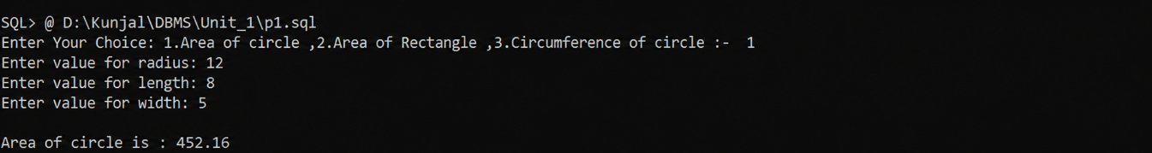

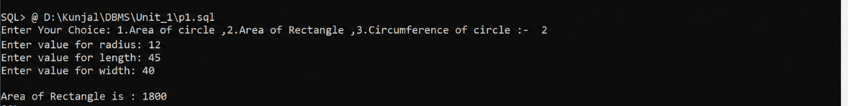

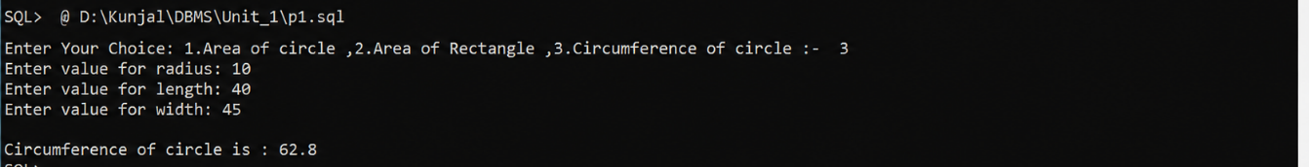

2. Write a PL/SQL block to accept product name, qty and price from user and then calculate discount in Rs. based on the given (%).

/*
Write a PL/SQL block to accept product name ,qty and price from user
and then calculate discount in Rs.based on the given (%)
*/

SET SERVEROUTPUT ON
SET VERIFY OFF
SET FEEDBACK OFF

ACCEPT PN PROMPT "Enter product name :- "
DECLARE
P_NAME VARCHAR(20);
QTY NUMBER(5);
PRICE NUMBER(7,2);
TP NUMBER(7,2);
DISCOUNT NUMBER(5);
FP NUMBER(7,2);
BEGIN
P_NAME:='&PN';
QTY:=&QTY;
PRICE:=&PRICE;
DISCOUNT:=&DISCOUNT;

TP:=PRICE*QTY;
FP:=TP-(TP*DISCOUNT/100);
DBMS_OUTPUT.PUT_LINE(' ');
DBMS_OUTPUT.PUT_LINE('Product name is := '||P_NAME);
DBMS_OUTPUT.PUT_LINE('Total qty is := '||QTY);
DBMS_OUTPUT.PUT_LINE('Price is := '||PRICE);
DBMS_OUTPUT.PUT_LINE('Total Price is := '||TP);
DBMS_OUTPUT.PUT_LINE('Discount is := '||DISCOUNT);
DBMS_OUTPUT.PUT_LINE('Final Price is := '||FP);

END;
/
SET SERVEROUTPUT OFF
SET VERIFY ON
SET FEEDBACK ON

Output:

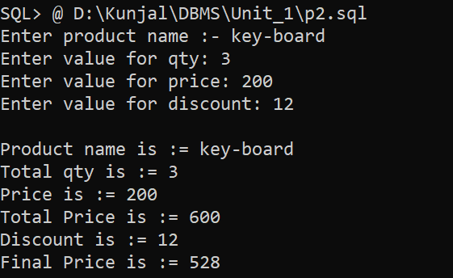

3. Write a PL/SQL block to calculate the total, percentage and grade of student based on his/her Rollno from RESULT table. (Create RESULT table with Rollno, Name, Sub1, Sub2, Sub3, Sub4, Sub5, Total, Per, Grade attributes with appropriate data type).

/*
Write a PL/SQL block to calculate the total, percentage and grade of
student based on his/her Rollno from RESULT table. (Create RESULT
table with Rollno, Name, Sub1, Sub2, Sub3, Sub4, Sub5, Total, Per,
Grade attributes with appropriate data type).
*/

SET SERVEROUTPUT ON
SET VERIFY OFF
SET FEEDBACK OFF
DECLARE
ROLL_NO NUMBER(5);
NAME VARCHAR2(30);
SUB1 NUMBER(3);
SUB2 NUMBER(3);
SUB3 NUMBER(3);
SUB4 NUMBER(3);
SUB5 NUMBER(3);
TOTAL NUMBER(5);
PER NUMBER(7,2);
GRADE VARCHAR2(30);
BEGIN
ROLL_NO:=&ROLL_NO;
NAME:='&NAME';
SUB1:=&SUB1;
SUB2 :=&SUB2 ;
SUB3 :=&SUB3 ;
SUB4:=&SUB4;
SUB5:=&SUB5;
TOTAL:=SUB1+SUB2+SUB3+SUB4+SUB5;
PER:=TOTAL/5;

IF (PER>=75) THEN
GRADE:='O';
ELSIF (PER<=75)AND(PER>=70) THEN
GRADE:='A';
ELSIF (PER<=60)AND(PER>=70) THEN
GRADE:='B';
ELSIF (PER<=50)AND(PER>=60) THEN
GRADE:='C';
ELSE
GRADE:='PASS CLASS';
END IF;

INSERT INTO RESULT(ROLLNO,NAME,SUB1,SUB2,SUB3,SUB4,SUB5,TOTAL,PER,GRADE)VALUES(ROLL_NO,NAME,SUB1,SUB2,SUB3,SUB4,SUB5,TOTAL,PER,GRADE);

DBMS_OUTPUT.PUT_LINE(' ');
DBMS_OUTPUT.PUT_LINE('Roll no:-'||ROLL_NO);
DBMS_OUTPUT.PUT_LINE('Name:-'||NAME);
DBMS_OUTPUT.PUT_LINE(' ');
DBMS_OUTPUT.PUT_LINE('---------------------Result--------------------------');
DBMS_OUTPUT.PUT_LINE('Marks of sub1:-'||SUB1);
DBMS_OUTPUT.PUT_LINE('Marks of sub2:-'||SUB2);
DBMS_OUTPUT.PUT_LINE('Marks of sub3:-'||SUB3);
DBMS_OUTPUT.PUT_LINE('Marks of sub4:-'||SUB4);
DBMS_OUTPUT.PUT_LINE('Marks of sub5:-'||SUB5);

DBMS_OUTPUT.PUT_LINE(' ');
DBMS_OUTPUT.PUT_LINE('-----------------------------------------------');
DBMS_OUTPUT.PUT_LINE('Your total marks : '||TOTAL);
DBMS_OUTPUT.PUT_LINE('Percentage :'||PER||'%');
DBMS_OUTPUT.PUT_LINE('Grade:'||GRADE);
END;
/

SET SERVEROUTPUT OFF
SET VERIFY ON
SET FEEDBACK ON

Output:

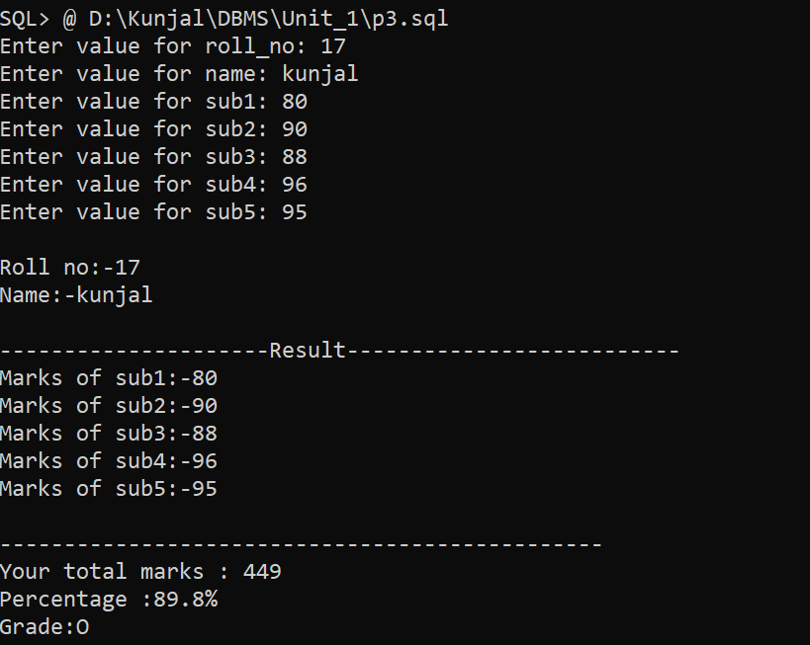

4. 1. Write a program that prints value 1 to 100 numbers using FOR LOOP.
2. Write a program that prints value 1 to 100 number using LOOP
Command.
3. Write a program that prints value 1 to 100 number using WHILE LOOP
Command

/*
1. Write a program that prints value 1 to 100 numbers using FOR LOOP.
2. Write a program that prints value 1 to 100 number using LOOP
Command.
3. Write a program that prints value 1 to 100 number using WHILE LOOP
Command
*/

SET SERVEROUTPUT ON
SET VERIFY OFF
SET FEEDBACK OFF

DECLARE
i NUMBER := 1;
BEGIN

-- FOR LOOP
DBMS_OUTPUT.PUT_LINE('--- FOR LOOP ---');
FOR i IN 1..100 LOOP
DBMS_OUTPUT.PUT(i || ' ');
END LOOP;
DBMS_OUTPUT.PUT_LINE(' ');

-- SIMPLE LOOP
DBMS_OUTPUT.PUT_LINE('--- SIMPLE LOOP ---');
i := 1;
LOOP
DBMS_OUTPUT.PUT(i || ' ');
i := i + 1;
EXIT WHEN i > 100;
END LOOP;
DBMS_OUTPUT.PUT_LINE(' ');
DBMS_OUTPUT.PUT_LINE('--- WHILE LOOP ---');
i := 1;
WHILE i <= 100 LOOP
DBMS_OUTPUT.PUT(i || ' ');
i := i + 1;
END LOOP;
DBMS_OUTPUT.PUT_LINE(' ');
END;
/
SET SERVEROUTPUT OFF
SET VERIFY ON
SET FEEDBACK ON

Output:

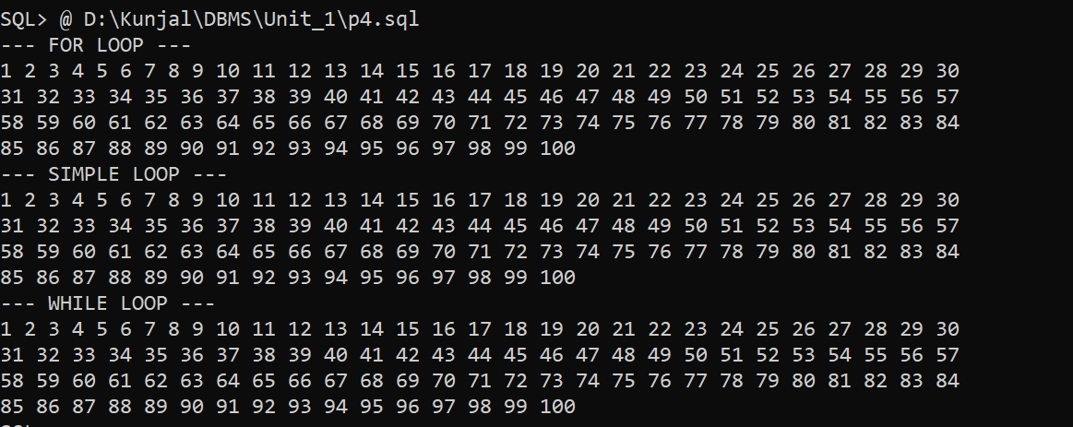

5. Write a PL/SQL block which displays gross salary of employees as per user input EID. (Consider EMP table with EID, EName, Deptno,Deptname Gender, Age, BasicSal) with appropriate data types.) Gross_Salary: BASICSAL + (DA + HRA + Medical) – PF. Rules: HRA = 15% of basic, DA = 50% of basic, Medical = Rs. 500, PF = 10% of basic.

/*
Write a PL/SQL block which displays gross salary of employees as per user input EID.
Consider EMP table with EID, EName, Deptno, Deptname, Gender, Age, BasicSal with appropriate data types.
Gross_Salary:= BASICSAL + (DA + HRA + Medical) – PF.
Rules: HRA = 15% of basic, DA = 50% of basic, Medical = Rs. 500, PF = 10% of basic.
Here for practical we have used Scott users inbuilt EMP table.
*/

SET SERVEROUTPUT ON
SET FEEDBACK OFF
SET VERIFY OFF

DECLARE
V_EID EMP.EID%TYPE;
V_NAME EMP.ENAME%TYPE;
BASIC_SAL EMP.BASICSAL%TYPE;
DA NUMBER;
HRA NUMBER;
MEDICAL NUMBER := 500;
PF NUMBER;
GROSS_SAL NUMBER;

BEGIN
V_EID := &EID;

SELECT ENAME, BASICSAL
INTO V_NAME, BASIC_SAL
FROM EMP
WHERE EID = V_EID;

DA := BASIC_SAL * 0.50;
HRA := BASIC_SAL * 0.15;
PF := BASIC_SAL * 0.10;
GROSS_SAL := BASIC_SAL + DA + HRA + MEDICAL - PF;

DBMS_OUTPUT.PUT_LINE('--------------- SALARY SLIP ---------------');
DBMS_OUTPUT.PUT_LINE('Employee ID : ' || V_EID);
DBMS_OUTPUT.PUT_LINE('Employee Name : ' || V_NAME);
DBMS_OUTPUT.PUT_LINE('Basic Salary : Rs. ' || BASIC_SAL);
DBMS_OUTPUT.PUT_LINE('DA Amount : Rs. ' || DA);
DBMS_OUTPUT.PUT_LINE('HRA Amount : Rs. ' || HRA);
DBMS_OUTPUT.PUT_LINE('Medical Amount : Rs. ' || MEDICAL);
DBMS_OUTPUT.PUT_LINE('Provident Fund : Rs. ' || PF);
DBMS_OUTPUT.PUT_LINE('--------------------------------------------');
DBMS_OUTPUT.PUT_LINE('Gross Salary : Rs. ' || GROSS_SAL);
DBMS_OUTPUT.PUT_LINE('--------------------------------------------');
EXCEPTION
WHEN NO_DATA_FOUND THEN
DBMS_OUTPUT.PUT_LINE(
'Employee record for given EID - ' || V_EID || ' does not exist'
);
END;
/

SET SERVEROUTPUT OFF
SET FEEDBACK ON
SET VERIFY ON

Output:
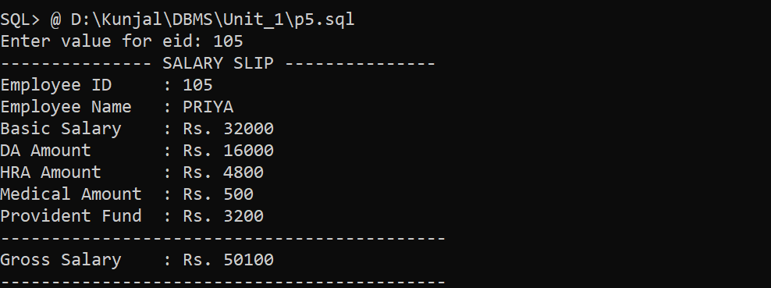
6. Write a PL/SQL block which accepts measurement in feet and displays it in cm, inch and meter.

/*
Write a PL/SQL block which accepts measurement in feet and displays it
in cm, inch and meter.

Formulas:-
1)Inches :-feet * 12
2)Centimeters :- feet * 30.48
3)Meters:-feet*0.3045
*/

SET SERVEROUTPUT ON
SET VERIFY OFF
SET FEEDBACK OFF

DECLARE
FEET NUMBER;
CM NUMBER;
INCH NUMBER;
METER NUMBER;
BEGIN
FEET := &FEET;

CM := FEET * 30.48;
INCH := FEET * 12;
METER := FEET * 0.3048;

DBMS_OUTPUT.PUT_LINE('Feet : ' || FEET);
DBMS_OUTPUT.PUT_LINE('Centimeter : ' || CM);
DBMS_OUTPUT.PUT_LINE('Inch : ' || INCH);
DBMS_OUTPUT.PUT_LINE('Meter : ' || METER);
END;
/

SET SERVEROUTPUT OFF
SET VERIFY ON
SET FEEDBACK ON

Output:
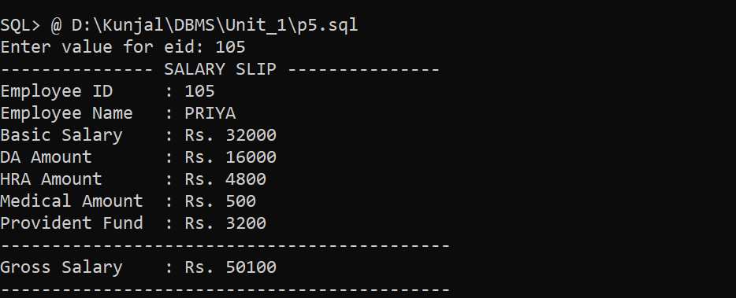

7. Write a PL/SQL block which converts temperature from Celsius to Fahrenheit.

/*
Write a PL/SQL block which converts temperature from Celsius to
Fahrenheit.
Formulas:-
-Celsius to Fahrenheit :-(Celsius *9/2)+32
-Fahrenheit to Celsius :-(Fahrenheit-32)/5/9
*/

SET SERVEROUTPUT ON
SET VERIFY OFF
SET FEEDBACK OFF
ACCEPT CH PROMPT 'Enter your choice :- 1. Celsius to Fahrenheit, 2. Fahrenheit to Celsius: '
DECLARE
CELSIUS NUMBER(10,2);
FAHRENHEIT NUMBER(10,2);
CHOICE NUMBER(10);
BEGIN
CHOICE := &CH;
IF CHOICE = 1 THEN
CELSIUS := &CELSIUS;
FAHRENHEIT := (CELSIUS * 9 / 5) + 32;

DBMS_OUTPUT.PUT_LINE('Value of FAHRENHEIT :- ' || FAHRENHEIT);

ELSIF CHOICE = 2 THEN
FAHRENHEIT := &FAHRENHEIT;
CELSIUS := (FAHRENHEIT - 32) * 5 / 9;
DBMS_OUTPUT.PUT_LINE('Value of CELSIUS :- ' || CELSIUS ||'C');
ELSE
DBMS_OUTPUT.PUT_LINE('INVALID CHOICE... Enter 1 or 2');
END IF;
END;
/

Output:
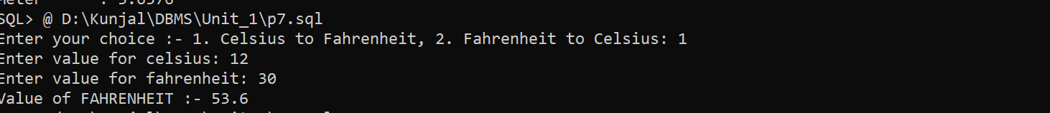

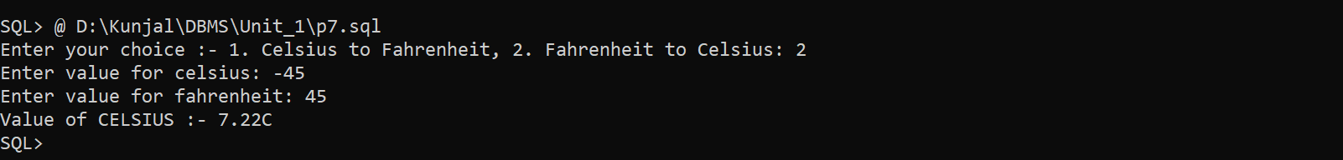

8. Write a PL/SQL block to delete the record of employee for given EID.
/*
Write a PL/SQL block to remove an employee record
for the given Employee ID.
*/

SET SERVEROUTPUT ON
SET FEEDBACK OFF
SET VERIFY OFF
DECLARE
EMP_ID EMP.EID%TYPE;
CNT NUMBER;
BEGIN
EMP_ID := &EID;

SELECT COUNT(*) INTO CNT FROM EMP WHERE EID = EMP_ID;

IF CNT > 0 THEN
DELETE FROM EMP WHERE EID = EMP_ID;

COMMIT;
DBMS_OUTPUT.PUT_LINE( 'Employee ID ' || EMP_ID || ' deleted successfully.' );
ELSE
DBMS_OUTPUT.PUT_LINE('Employee ID ' || EMP_ID || ' does not exist.' );
END IF;

END;
/
SET SERVEROUTPUT OFF
SET FEEDBACK ON
SET VERIFY ON

Output:
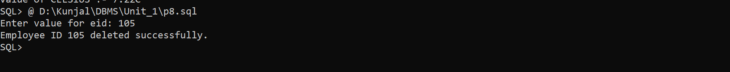

9. Write a PL/SQL block that calculates the simple interest based on given principal amount, rate of interest and number of years.

/* Write a PL/SQL block to calculate Simple Interestand Total Amount. */

SET SERVEROUTPUT ON
SET FEEDBACK OFF
SET VERIFY OFF
DECLARE
P NUMBER;
R NUMBER;
T NUMBER;
SI NUMBER;
AMOUNT NUMBER;
BEGIN
P := &P;
R := &R;
T := &T;
SI := (P * R * T) / 100;
AMOUNT := P + SI;
DBMS_OUTPUT.PUT_LINE('========================');
DBMS_OUTPUT.PUT_LINE('Principal Amount : ' || P);
DBMS_OUTPUT.PUT_LINE('Rate of Interest : ' || R || '%');
DBMS_OUTPUT.PUT_LINE('Number of Years : ' || T);
DBMS_OUTPUT.PUT_LINE('Simple Interest : ' || SI);
DBMS_OUTPUT.PUT_LINE('Total Amount : ' || AMOUNT);
END;
/
SET SERVEROUTPUT OFF
SET FEEDBACK ON
SET VERIFY ON
Output:
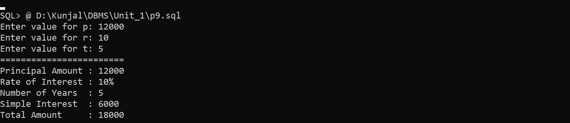

10. Write a PL/SQL block to calculate the square and cube of the given number.

/*
Write a PL/SQL block to calculate the square and cube
of the given number.
*/

SET SERVEROUTPUT ON
SET FEEDBACK OFF
SET VERIFY OFF

DECLARE
N NUMBER;
SQUARE NUMBER;
CUBE NUMBER;
BEGIN
N := &N;
SQUARE := N * N;
CUBE := N * N * N;

DBMS_OUTPUT.PUT_LINE('Given Number : ' || N);
DBMS_OUTPUT.PUT_LINE('Square : ' || SQUARE);
DBMS_OUTPUT.PUT_LINE('Cube : ' || CUBE);

END;
/

SET SERVEROUTPUT OFF
SET FEEDBACK ON
SET VERIFY ON

Output:
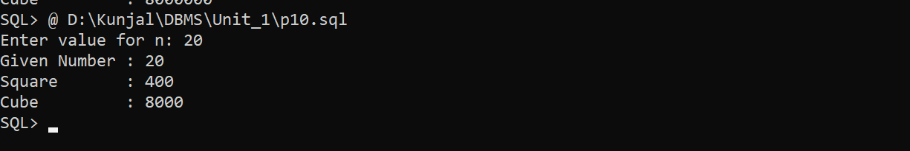

11. Write a simple procedure that increases by the salary of employees for the given department no. by percentage inputted by the user using IN parameter. Also handle the exception if inputted department number not found.

/*
Write a simple procedure that increases by the salary of employees for the given department no. by percentage inputted by the user using IN parameter. Also handle the exception if inputted department number not found.
*/

SET SERVEROUTPUT ON
SET VERIFY OFF
SET FEEDBACK OFF

CREATE OR REPLACE PROCEDURE increase_salary (
p_deptno IN NUMBER,
p_percent IN NUMBER
)
IS
v_count NUMBER;
BEGIN
SELECT COUNT(*)
INTO v_count
FROM EMP
WHERE DEPTNO = p_deptno;

IF v_count = 0 THEN
RAISE_APPLICATION_ERROR(
-20001,
'Department number ' || p_deptno || ' not found'
);
END IF;

UPDATE EMP
SET BASICSAL = BASICSAL + (BASICSAL * p_percent / 100)
WHERE DEPTNO = p_deptno;

COMMIT;

DBMS_OUTPUT.PUT_LINE(
'Salary increased by ' || p_percent ||
'% for department ' || p_deptno
);

EXCEPTION
WHEN OTHERS THEN
DBMS_OUTPUT.PUT_LINE('Error: ' || SQLERRM);
END;
/
SET SERVEROUTPUT OFF
SET VERIFY ON
SET FEEDBACK ON

Output:

12. Write a procedure that search whether the given employee number is present or not in the table if present then print name, salary and department number of that employee. (Use both IN and OUT mode variables) and also Write a PL/SQL block to call the SEARCH_EMP procedure.

/*
Write a procedure that search whether the given employee number is
present or not in the table if present then print name, salary and
department number of that employee. (Use both IN and OUT mode
variables) and also Write a PL/SQL block to call the SEARCH_EMP
procedure.
*/

SET SERVEROUTPUT ON
SET VERIFY OFF
SET FEEDBACK OFF

CREATE OR REPLACE PROCEDURE SEARCH_EMP (
P_EID IN NUMBER,
P_ENAME OUT VARCHAR2,
P_SALARY OUT NUMBER,
P_DEPTNO OUT NUMBER
)
IS
BEGIN
SELECT ENAME, BASICSAL, DEPTNO
INTO P_ENAME, P_SALARY, P_DEPTNO
FROM EMP
WHERE EID = P_EID;

EXCEPTION
WHEN NO_DATA_FOUND THEN
P_ENAME := NULL;
P_SALARY := NULL;
P_DEPTNO := NULL;

DBMS_OUTPUT.PUT_LINE(
'Employee number ' || P_EID || ' not found.'
);
END;
/

SET SERVEROUTPUT OFF
SET VERIFY ON
SET FEEDBACK ON

Output:

13. Write a procedure that accept employee ID and remove records from employee table. Also create a calling program to call procedure.

/*
Write a procedure that accept employee ID and remove records from employee table. Also create a calling program to call procedure.
*/

SET SERVEROUTPUT ON
SET VERIFY OFF
SET FEEDBACK OFF

CREATE OR REPLACE PROCEDURE REMOVE_EMPLOYEE (
P_EID IN EMP.EID%TYPE
)
IS
BEGIN
DELETE FROM EMP
WHERE EID = P_EID;

IF SQL%ROWCOUNT = 0 THEN
DBMS_OUTPUT.PUT_LINE(
'Employee ID ' || P_EID || ' not found.'
);
ELSE
DBMS_OUTPUT.PUT_LINE(
'Employee ID ' || P_EID || ' deleted successfully.'
);
END IF;

END;
/

SET SERVEROUTPUT OFF
SET VERIFY ON
SET FEEDBACK ON

Output:

14. Write a function that returns the age, category of an employee.
Categories:
● Age < 18 → Minor
● 18–60 → Adult
● 60 → Senior

/*
Write a function that returns the age, category of an employee.
Categories:
● Age < 18 → Minor
● 18–60 → Adult
● 60 → Senior
*/
SET SERVEROUTPUT ON
SET VERIFY OFF
SET FEEDBACK OFF

CREATE OR REPLACE FUNCTION GET_AGE_CATEGORY (
P_EID IN NUMBER
)
RETURN VARCHAR2
IS
V_AGE EMP.AGE%TYPE;
V_CATEGORY VARCHAR2(20);
BEGIN
SELECT AGE
INTO V_AGE
FROM EMP
WHERE EID = P_EID;

IF V_AGE < 18 THEN
V_CATEGORY := 'Minor';
ELSIF V_AGE <= 60 THEN
V_CATEGORY := 'Adult';
ELSE
V_CATEGORY := 'Senior';
END IF;

RETURN 'Age: ' || V_AGE || ', Category: ' || V_CATEGORY;

EXCEPTION
WHEN NO_DATA_FOUND THEN
RETURN 'Employee not found';
END;
/

SET SERVEROUTPUT OFF
SET VERIFY ON
SET FEEDBACK ON

Output:

15. Write a PACKAGE which includes Package Declaration, Package Body and call the individual object from the Package.

/*
Write a PACKAGE which includes Package Declaration, Package Body and call the individual object from the Package.
*/

SET SERVEROUTPUT ON
SET VERIFY OFF
SET FEEDBACK OFF

CREATE OR REPLACE PACKAGE my_package
AS
PROCEDURE greet;
END my_package;
/

CREATE OR REPLACE PACKAGE BODY my_package
AS
PROCEDURE greet
IS
BEGIN
DBMS_OUTPUT.PUT_LINE('Hello World');
END greet;
END my_package;
/

BEGIN
my_package.greet;
END;
/

SET SERVEROUTPUT OFF
SET VERIFY ON
SET FEEDBACK ON

Output:

